New Service Request
- Go to the F&S Portal https://my.fs.illinois.edu/fsportal/portal/
- Click on Service Request
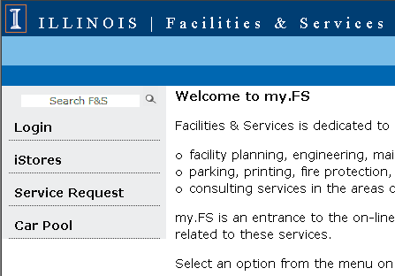

If you have not logged into the portal, you will be required to login:

Login to the portal
- Go to the F&S Portal https://my.fs.illinois.edu/fsportal/portal/
- Start the log process by selecting the Login option from the menu
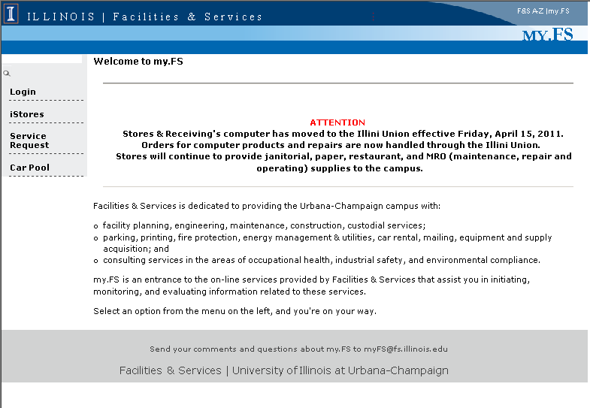

Select the Login option from the menu of options

Please note- informational messages may be displayed in this area to communicate with the end users.

- Key your University NetID (this is your BlueStem/Nessie Login) and press Continue
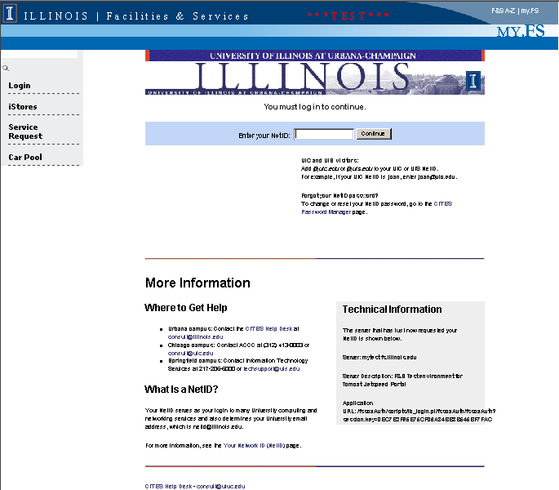

- Press Continue
- Enter your BlueStem / Nessie NetID

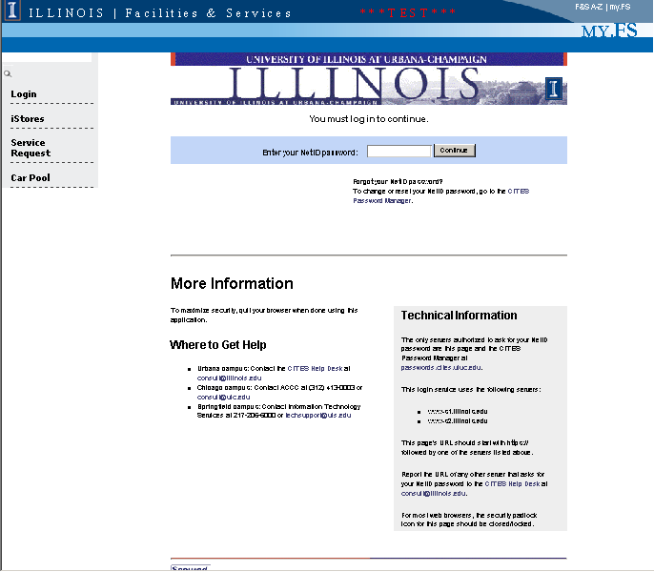
- Key your University NetID password and press Continue

- Enter your BlueStem NetID password
- Press Continue

Add Service Request Details (Required)
- Select Type of Request:
  - Service Request (default)
  - Contractor Services
- Fill in Desired Comp. Date: (optional, does not drive work - for informational purposes only)
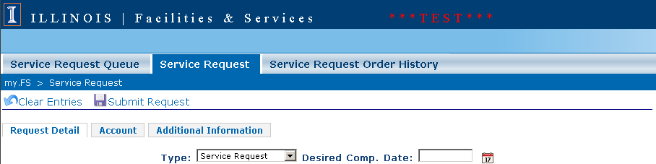

- The Entry Person, Requestor, and Primary Contact default to the person logged in.
  - You can change the Requestor and Primary Contact by click on the icon.
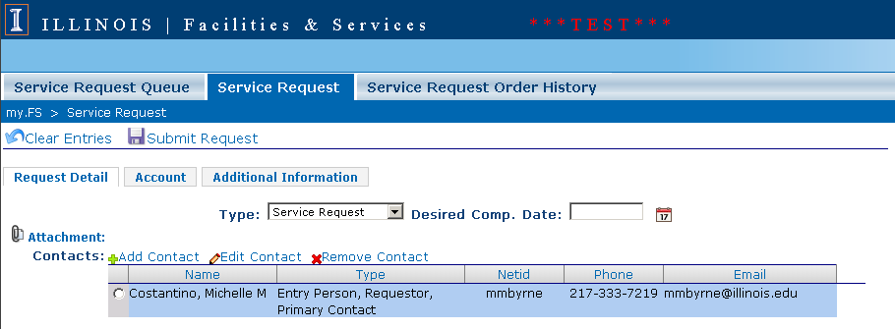
- Fill in the NetID and press the “TAB” key (System will fill in the Employee Details)
- Click the box(es) next to:
  - Requestor
  - Primary Contact
- Other people can be an additional Contact, go back to Step 3 then Check Contact box
- Click the button.

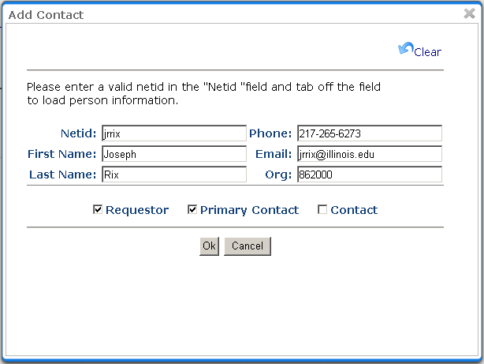
- Fill in the Building Number (4 digit number)
OR
- Type part of the Building Name and press the Look-up Icon .
- Click the Bldg Number.
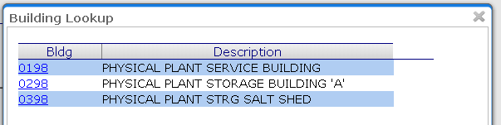
- Select the Room (optional)
- Fill in the Work Order Description.
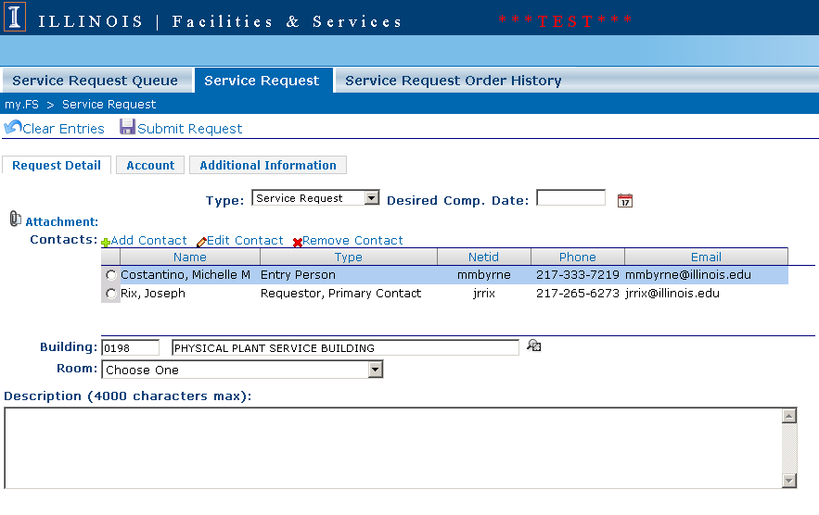
- After review of the information supplied, you must select the Account information for the Service Request

Adding Account Information (Required)
- Click on the Account “Tab”
- Select the “Bullet” next to the AIM Account to be charged. (these are the accounts associated with the requestor)
  - NOTE: there is a drop down list to display COLLEGE ACCOUNTS
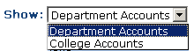
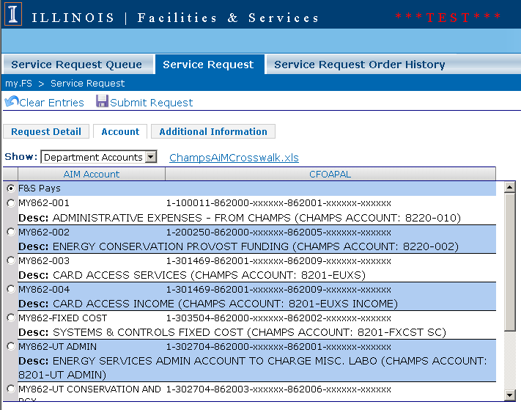

Adding Additional Information (Optional)
- Click on the Additional Information “Tab”
- All of these fields are Optional. Fill in as necessary.
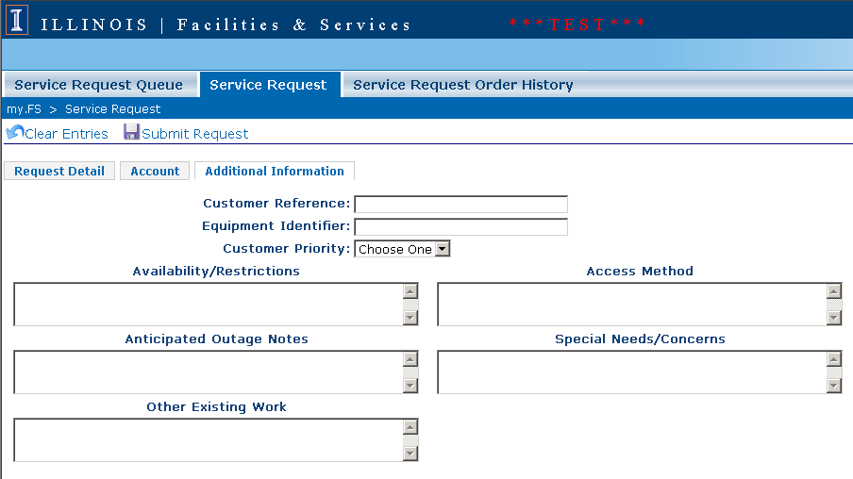

Attaching a Document to a Service Request
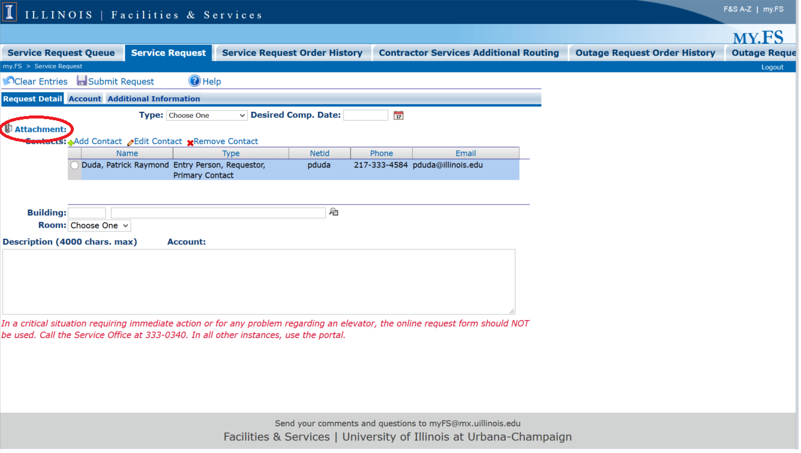
- Select the Attachment icon
- Use the dialog box to upload files: 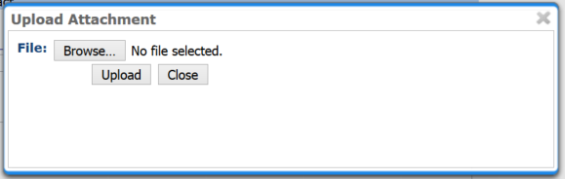

Submitting Request to Service Office

Press the Icon.
Your Service Request Number will be displayed:

